Lab 21: Spring Framework

Objective
This lab will introduce you to the basic concepts of the Spring Framework. The lab steps are:

- Create a Java project using the Spring libraries
- Implement and deploy a Spring Bean

Step by Step Guide

Step by Step Instructions

In this lab, you will be creating a standard Java project that uses the Spring via adding the Spring Framework jar files to the build path.

Add a new project and download the Spring Libraries

- Create a new Project in your workspace named Consult.
- Add a new package to the project named com.consulting
- Download the latest Spring jars from here:

https://repo.spring.io/ui/native/release/org/springframework/spring/5.3.9/

- At the time this was written, the latest version was 5.3.9 but you may have the option of downloading a more recent version.

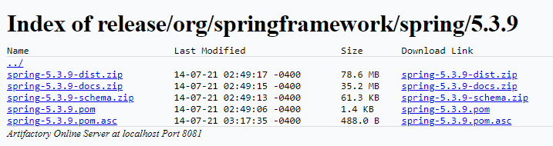
- Download and unzip the “*dist.zip” file anywhere, the “Downloads” directory if fine for this lab.

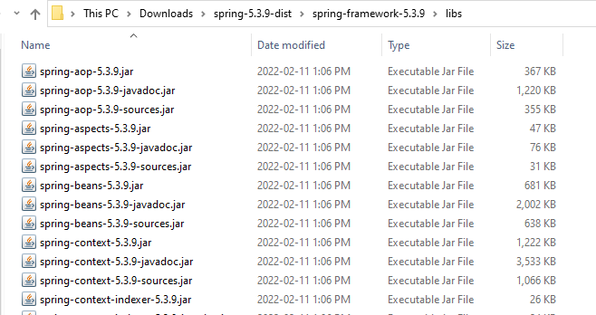
You should see something that looks like this:

Add the Spring Jars to the project build path

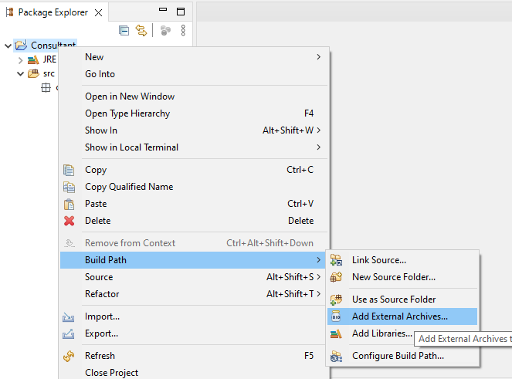
- Right click on the project folder and select the “Build Path” option and the “Add external archives” option.

- Using the file browser, go to the directory with the Spring jar files, select them all and then add them using the “Open” option.
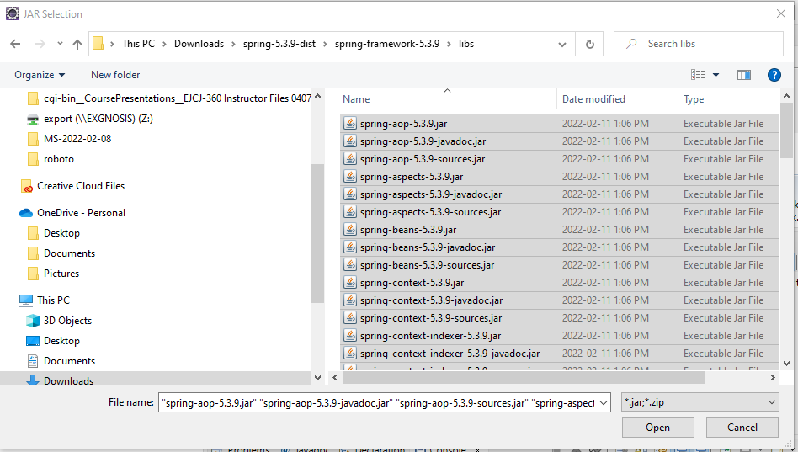

- If successful, you should see the jars appearing under a new folder called “referenced libraries”

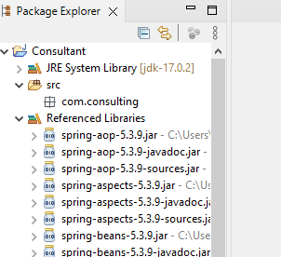
Create the Spring bean interface

Remember that the Spring bean is a proxy POJOs that implement that interface. The client code is written to the interface and Spring is responsible for selecting the actual implementation class that we specify in our Spring configuration.

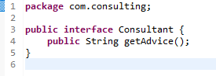
- Create a Java Interface with a single method called “getAdvice()” that returns a string.

- Create an implementation called “ITPerson” that implements the interface and returns the advice “Turn it off and on again.”

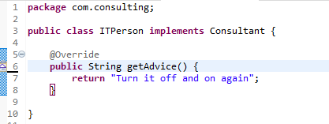
- Create another implementation called “PRPerson” that implements the interface and returns the advice “Never let them see you sweat”

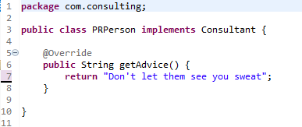

Create the configuration file

- The XML configuration file must be compliant to a specific schema.
- Copy the boilerplate code to a file in your package directory called “config.xml”
- Add the line shown below to direct Spring to scan for annotations

<?xml version="1.0" encoding="UTF-8"?>
<beans xmlns="http://www.springframework.org/schema/beans"
xmlns:xsi="http://www.w3.org/2001/XMLSchema-instance"
xmlns:context="http://www.springframework.org/schema/context"
xsi:schemaLocation="http://www.springframework.org/schema/beans
http://www.springframework.org/schema/beans/spring-beans.xsd
http://www.springframework.org/schema/context
http://www.springframework.org/schema/context/spring-context.xsd">

<!-- add entry to enable component scanning -->

<context:component-scan base-package="com.consuting" />

</beans>

Create the Annotations of the Components

- Add the @Component annotation to the two ITPerson and PRPerson classes: for this lab, you will use the default bean names based on the names of the classes

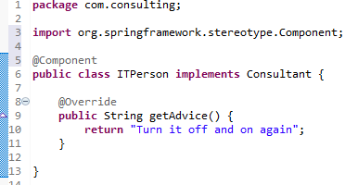
.
Create the Application Class

- Create the Spring context from the configuration file

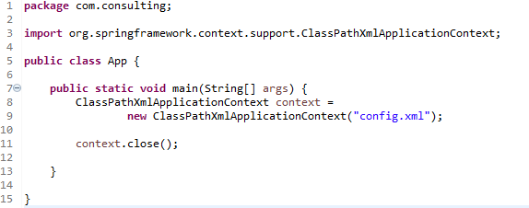

Request Beans from the Context

- Ask the container to create some beans to be used
- What is returned is a POJO that is created by the context
- If a POJO of that type exists, a reference to it is returned instead of creating a new instance
- This is the singleton default behavior.
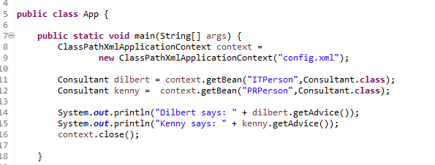

- To see that you are working with singletons, compare two ITPerson beans to see if they resolve to the same object address in memory.

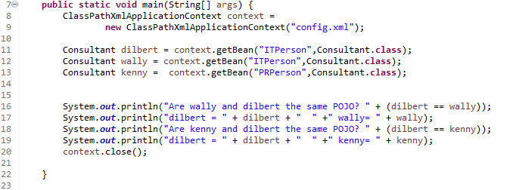
- The output of the above should look like this

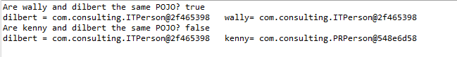
Prototype Beans

- You can specify that every time a bean is created from a class, a new instance of the POJO is used.
- The @Scope annotation is used
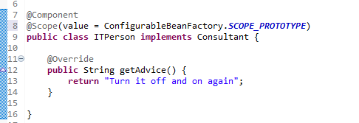

- Adding the annotation and rerunning the application without any other changes will show that the two ITPerson beans are distinct instances

